Bio Note
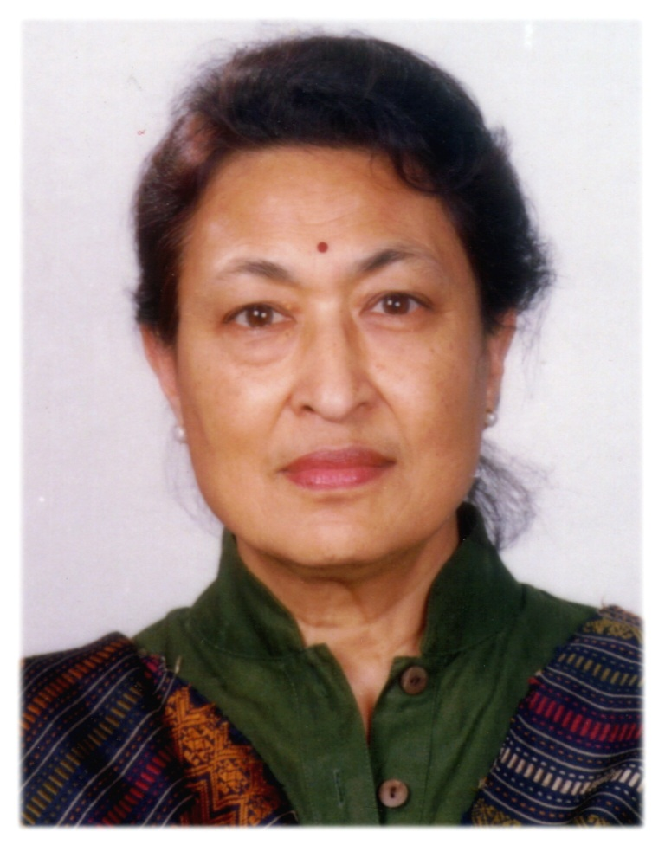
“Bina Pradhan" has a Ph.D in Population and Development (PDP) from Cornell University with a multidisciplinary background in rural sociology, economics, gender studies, anthropology and international development. She is an independent researcher, Socio-economist/Gender Specialist affiliated to SEN (Sustainable Energy Nepal), a private development concern promoting use of renewable energy towards saving environmental resource depletion. She is currently, pursuing research on gender and macroeconomics from gender and social inclusion perspective, and proactively promoting reproductive health and rights of women, pro-poor development strategy with gender justice, gender management system (GMS), and post conflict transformation for gender and social equality. Recipient of Fulbright New Century Scholars programme (2009-2010) affiliated to University of California, Berkeley as Resident Scholar where she carried out research on Inclusive Macroeconomic Framework. She served as Technical Adviser in the Social Development Sector, National Planning Commission (NPC)/GON for introducing Gender Management System (GMS) within Administrative System of Government of Nepal, and preparation of the Three Year Interim Plan (TYIP), 2007-2010, for post conflict reconstruction and rehabilitation of Nepalese economy.
She has over 30 years of professional and technical experiences in research and teaching; programme/project design, implementation, and monitoring/evaluation; regional, national and local capacity building; and policy advocacy at local and regional and international levels in gender and development, and population and reproductive health.
She served as the FAO Regional Adviser on Gender and Socio-Cultural Operations Research to UNFPA/CST from 1998 to 2003. During her tenure she provided technical support in country programme development and management, socio-cultural research, monitoring and evaluation, and capacity development in areas of gender, population and reproductive health in the countries of South, Central and West Asia.
From 1992 to 1997, Pradhan undertook short term assignments in various capacities in the fields of gender and development, some of which were: Visiting Professor in the Institute of Gender Studies in Ochanomizu University in Tokyo, Japan; Gender and Development Expert for the Ministry of Women’s Affairs and Social Welfare of the Government of Maldives; Resource Person at Padma Kanya Campus, Tribhuvan University (1995) for development and establishment of Post Graduate Programme in Gender Studies including conduction of intensive course on Gender and Development for capacity development of the Faculty Members for operation of the programme; and WID Consultant to Canadian Cooperation Office/CIDA, Kathmandu (1993-1995) for mainstreaming gender in policy and programme development . She provided technical support services for various international agencies such as FAO, UNICEF, UNIFEM, UNIDO, UNFPA, USAID, IDRC and IFAD in areas of gender and development, population, maternal and reproductive health and micro credit financing.
From 1983 to 1989/90, Pradhan established the first women NGO in Nepal, Centre for Women and Development, and served as Executive Director in building the Centre and in the promotion of gender equality and empowerment of women. In 1998 she was awarded the Hubert Humphrey Fellowship in recognition of her significant contributions to public services and in promotion of gender issues and empowerment of women.
In the 1970’s, under the Tribhuvan University, Nepal, she under took teaching and a wide range of research projects including the land mark study on The Status of Women in Nepal. This study was a major contribution in the field of gender and development as well as in the development of methodology in giving visibility to women’s work and their contribution to the household economy. She authored 2 monographs on Status of Women in Nepal, Women’s Autonomy and Reproductive Health Behavior and has written extensively on the subject.
Pradhan is member of Society of International Development/Rome (SID) and a member of the National Chapter and has actively contributed in strengthening the Chapter as well as establishing links with the SID international and South Asia regional net work (SID-SAN) in the promotion of reproductive health, rights and gender concerns in development and conflict transformation from the perspective of gender and social inclusion. She is also an active Member of the Regional Task Force for WHRAP/Asian-Pacific Resource and Research Centre for Women (ARROW), Kuala Lumpur, Malaysia pursuing to develop and incorporate data base on maternal and reproductive health under SAARC Gender Infor- Data base
Mailing Address: P. O. Box 3637, Kathmandu, Nepal
Telephone: +977 1 5539159, Fax: +977 1 5532121, Mobile: (977) 98510 01799
E-mail address: afda@wlink.com.np; binapradhan44@gmail.com

