Ajay Murmu

**Curriculum Vitae**

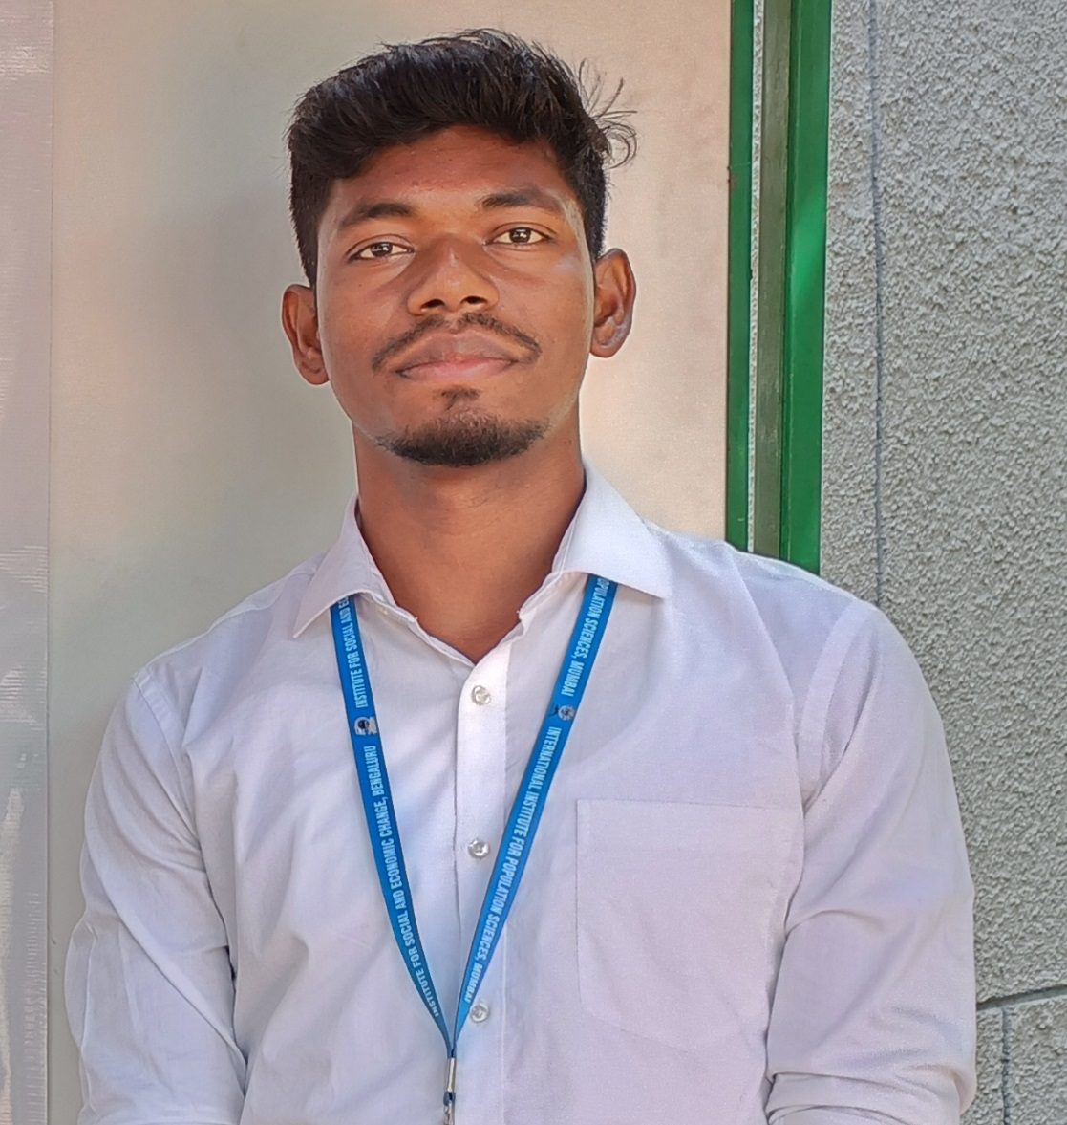

* **PhD. Candidate in Population Studies, International Institute for Population Sciences, Mumbai (Currently Enrolled)**
* **Pre-PhD in Population Studies**
* **Master in Population Studies (MPS)**
* **Master of Arts (MA) in Geography and**
* **Bachelor of Arts (B.A) in Geography**

 **+91-9091049904** [ajaymurmuasn@gmail.com](mailto:ajaymurmuasn@gmail.com)

<https://orcid.org/0009-0008-9580-2415>

 **S/O Mina Murmu, Vill-Khayer Danga, P.O: Chelod, PS: Raniganj, District: Paschim Bardhaman, State: West Bengal, Pin code – 713339**

**Current Address**: **International Institute for Population Sciences, Govandi Station Road, Mumbai-400088**

 **Research Interest**

Migration, Urbanization, Tribal studies, Spatial Demography

**Education Qualification**



#### 

**Pre-PhD Coursework (2022-2023)**

* International Institute for Population Sciences, Mumbai, Maharashtra, India
* Percentage – 75.4

**M.A. (Geography) (2019-2021)**

* Visva- Bharati University, Santiniketan, Bolpur, West Bengal
* Percentage – 79.60

**12th Standard (2016)**

* West Bengal Council of Higher Secondary Education (WBCHSE)
* Percentage – 88.40

#### MPS (Population Studies) (2021-2022)

* International Institute for Population Sciences, Mumbai, Maharashtra, India
* Percentage – 67.20

**B.A Honours (Geography) (2016-2019)**

* The University of Burdwan, Purba Bardhaman, West Bengal, India
* Percentage – 70.12

**10th Standard (2014)**

* West Bengal Board of Secondary Education (WBBSE)
* Percentage – 78.28

3,583 Technical Skills Icon Images, Stock Photos, 3D objects ...**TECHNICAL SKILLS**

* + - Expertise in handling large scale survey data such as **Census Data**, the **Longitudinal Aging Study in India** (LASI), **India Human Development Survey** (IHDS), **National Sample Survey** (NSS), etc., using Statistical Packages such as **STATA** and **SPSS**. Basic knowledge of **R** software.
    - Possessing advanced expertise in navigating **QGIS**, **ArcGIS**, **Google Earth Engine**, GeoDA, **MORTPAK**, and **Spectrum**.

**AWARDS & SCHOLARSHIPS**

* Qualified National Eligibility Test (NET) for Assistant Professor in **Geography** (December, 2020)
* Qualified Junior Research Fellowship (JRF) in **Geography** (March, 2022)
* Qualified State Eligibility Test (SET) for Assistant Professor in **Geography** (March,2023)
* Qualified National Eligibility Test (NET) for Assistant Professor in **Population Studies** (February, 2024)

 **RESEARCH EXPERIENCE**

* **Pre-PhD Course work (2022-2023)**

**Secondary Paper-** The association between living arrangement and depression symptoms among older population in India: Differential between migrant and Non-Migrant

**Review Based Paper**- Migration and Regional Disparities in India

* **MPS Term Paper (2022)**

Urbanization of Scheduled Tribes in India

* **Master’s Dissertation (2021)**

Open cast coal mining: associated environmental and social problems in Raniganj Block, Paschim Bardhaman District, West Bengal, India

* **B.A Field Work (2019)**

Appraisal of Newly Developed Ward No.24 of Bankura Municipality in the context of its Socio-Economic Profile and a Study on Skyline Development

 **WORK EXPERIENCE**

* + Working as **Junior Research Fellow, from 2022, July** at International Institute for Population Sciences, Mumbai.
* **PUBLICATIONS**

**Published**

1)Munda, J., & Murmu, A. (2024). Rashtriya Swasthya Bima Yojana (RSBY) Availing Among Middle and Old Age Migrants: A Study of National Health Insurance Programme in India. In Population, Environment and Disease: Towards Health Geography (pp. 99-118). Cham: Springer Nature Switzerland.

2) Dutta, A., & Murmu, A. (2024). Prevalence and determinants of HIV testing among men in India: Insights from NFHS-5. Clinical Epidemiology and Global Health, 30, 101855.

**Currently Under Review**

1)  Muhammad, T., Pai, M., Rishad, M., **Murmu, A**., Afsal, K., & Ali, W K. “Migrant status, loneliness and social isolation among older Indian adults: the role of gender and rural/urban residence” BMC Geriatrics.

2) Murmu, A. “Urbanization and Residential segregation of Tribal population in Indian urban centres” GeoJournal.

3) Murmu, A., & Munda, J. “Contribution of Migration in Growth of Major Urban Agglomerations in India” Urban India.

4) Munda, J., & Murmu, A. “Frequency of Health Camps visits among SC, ST, and Other Social Category Populations in India” Sociological Bulletin.

**Working Papers**

1) Are migration status and low life satisfaction associated with poor sleep quality in older adults? Evidence from LASI data

2) Migration in later life and its association with cognitive impairment among middle-aged and older adults in India

3) Regional Disparities of Social Welfare Schemes among Elderly Population in India: Evidence from LASI, Wave-1

4) Impact of Migration and Population Dynamics on Million-Plus Cities in India

* **CONFERENCES/ WORKSHOP/ PAPER PRESENTATIONS**
  + Presented a paper (**Oral**) **Onsite** at **35th International Geographical Congress “Urbanization and Residential segregation of Tribal population in Indian Cities”** at Dublin, Ireland from 24-30 August, 2024.
  + Presented a paper (**Oral**) **Onsite** at the **44th Annual Conference of the IASP “The association between living arrangement and depression symptoms among older population in India: Differential between migrant and Non-Migrant” scheduled during** 8 – 10th, November 2023at NIT, Rourkela, Odisha.
  + Presented a paper (**Oral**) **Onsite** at **XXVII IIPS National Seminar of IIPS 2022-23 “Urbanization of Tribal Population in India”** at ISEC, Bangalore from 23-25 February, 2023.
  + Participated in **6-Day Online FDP on “Qualitative Research and Data Analysis in Public Health and Social Sciences for Research and Impact Evaluations 2.0**.” conducted by School of Public Health, SRM IST, Tamil Nadu, India.
  + Participated in **5 Days Capacity Building Workshop on “Researching Invisible Populations: Theory & Practice”, (Onsite)** 3-7 October, 2023 at Centre for Labour Studies and Practices, TISS, Mumbai.
  + Participated in **5 Days Capacity Building Workshop on “Five-day Capacity building workshop on large-scale data for Health Research”, (Onsite)** 24-28th July, 2023 at Gokhale Institute of Politics and Economics, Pune
  + Participated in **5 Days online International workshop on “Researching Labour Migration in South Asia: Data, Methods and Theory”, 13**-17 December, 2022 organized by SALAM –IIPS
  + Participated in the **for hands-on training on Use of GRIDDED POPULATION DATA**" 6-7 September, 2022 of join collaboration of IIPS (India) and INED(France) at IIPS, Mumbai
  + Participated **“21 days online GIS training program using QGIS”** conducted by the Department of Geography, Central University of Karnataka, India jointly with the state Institute of Urban Development, Karnataka, India from13 th July to 2nd august,2020.
  + Participated **one-week QGIS Training Program International Level for The Development of GIS Platform**, held on 12th august to 18th august,2020 Conducted by Geotech GIS Training Institute, Aurangabad.

**STRENGTHS**

* Motivated to achieve assigned target to near perfection Fast learning ability enabling quick adaptation to changes
* Ability to draft solutions in challenging situations independently and/ involving peer group.

 MEMBERSHIP

* IIPS Alumni Association (IIPSAA)
* Asian Population Association (APA)
* Indian Association for the Study of Population (IASP)

**LANGUAGES KNOWN**

* English (fluent), Bengali (native), Hindi (fluent), **Santhali** (Mother Tongue)

**REFERENCES**

|  |
| --- |
| **Dr. Kunal Keshri**  **Assistant professor**  Department of Migration and Urban Studies  International Institute for Population Sciences  Mumbai - 400088  **Mail Id**: kunal.keshri@iipsindia.ac.in  **Contact no**: +91 8303697775 |
| **Prof. R. B. Bhagat**  **Former Professor & Head**  Department of Migration and Urban Studies  International Institute for Population Sciences  Mumbai - 400088  **Mail Id**: rbbhagat@iipsindia.ac.in  **Contact no**: +91 9987014172 |

**DECLARATION**

Hereby, I assure that the information furnished above is true. Further, If I get an opportunity to work

in your concern, I assure that I shall discharge my duties to the best of my ability.

I sincerely thank you for kind consideration in going through my application for the post at

your esteemed organization.

**Thank you** **Yours Sincerely**,

