IUSSP – Search Features

Through the use of CiviCRM, the IUSSP administrators will be able to realize advanced searches on members and events in back office.

Yet, other search features have to be set up in front office on two different cases :

* general content search (through the use of the search box on the upper right corner of the header)
* advanced members search through the feature called « member directory »

1. General Content Search

On all pages of the website, a search box is available on the top right corner of the pages.

A search through this box opens a result page listing all the related results. These results are results that find the occurrence you searched for in any standard content of the website.

This search is enabled by the Drupal Search API (<http://drupal.org/project/search_api>) and displays results under a view described below:

* Results are displayed by antechronoligical order
* Number of results is described on the upper left side of the page with the following phrase: “X results for Y”, X being the number of results, Y the word(s) you searched for.
* Each result is displayed under the following view:
  + Page title
  + Date
  + Author of the content (in admin)
  + 3 first lines of the page content, max 100 words
  + tags (if tags have been assigned to the content when creating it in BO)
  + “Read more” link that sends to the relevant page
* Maximum 10 results are displayed on a page. If more than 10 results available, a pagination is available at the bottom of the page with ability to go to the first page, the last page, the 5 previous pages and the 5 next pages.
* If less than 11 results, pagination is not displayed

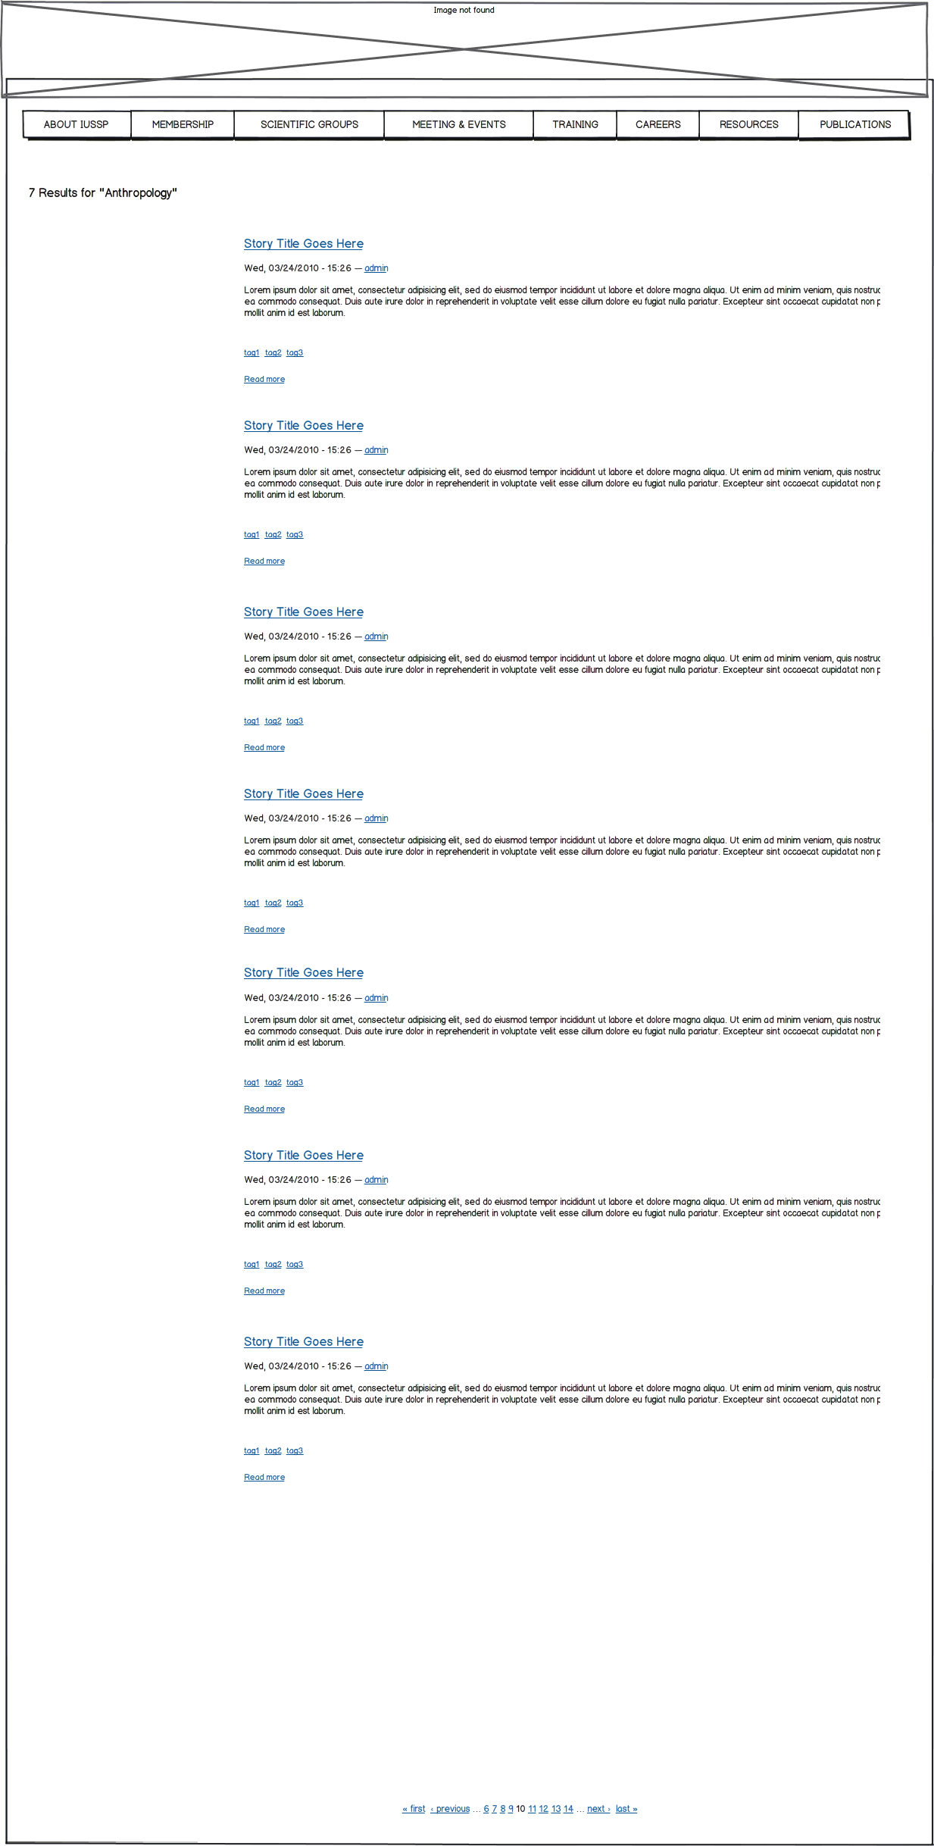

1. Members Directory Search

The members directory enable members to search the IUSSP members database for info on a specific person.

* 1. Member Page

Each member, when he has edited a part of his profile (see edit my profile), has a profile view that can be displayed in the members directory (if he agreed to).

This directory page is as follows :

A description...

It shows various elements taken from the member civi profile such as :

* Top Left space : picture, address, phones, Nationality, Gender (from « edit my profile »)
* Body : Display Full Name, Position (comma), Institution, email, professional and/or personal webapges, areas of specialization (Field of Study, Specialization, Regional focus), education, working languages, (from « edit my profile »), summary (from my CV), activities (as listed in BO), publications (from my CV), Honorary positions (from BO), Research grants, Member of other associations
* Add CV to download, preferably more than on if possible – but that means adding on the registration side too.
  1. Directory search

To access a specific member page, you can use the members directory page which offers a search facility on various civi fields.

Results are displayed under the civi grid format with access to members page through the « view member » button.

Lists are sortable

Max 20 members by page.

If more than 20 results available, a pagination is available at the bottom of the page with ability to go to the first page, the last page, the 5 previous pages and the 5 next pages.

If less than 21 results, pagination is not displayed.

1) Searches can be done:

⇒ In one or more of the “CIVI” fields

2) Searchable fields:

- Name [This search should search in “Last Name” and “First name”].

- Field of Study/Discipline:

- Specialisations:

- Regional focus:

- Working languages:

- Country of Residence:

- Nationality

- Region of residence [based on grouping of countries by Philippe, associated to countries]

- Other association

- Sex

- Membership status: full member / Student

- Institution

- Highest degree?

- University of highest degree?

4) Directory Search by criteria:

Directory Search by criteria: Search

• Name: write-in (autocomplete)

• Institution: write-in (autocomplete)

• Country of Residence: drop-down and tick (one only)

• Nationality: drop-down and tick (one only)

• Field of Study/Discipline: pop-up and tick (one or more)

• Specialisations: pop-up and tick (one or more)

• Regional focus: pop-up and tick (one or more)

• Working languages: pop-up and tick (one or more)

• Region of residence: pop-up and tick (one or more)

• Other association: pop-up and tick (one or more)

• Sex: tick

• Membership status: tick

• Highest degree? tick

• University of highest degree? write-in (autocomplete)

*When you use more than one search field it must be clear that your search results will display only those who match all requirements (“and” not “or”).

*When you tick more than one item in a field it must be clear that your search results will display all those who match any of the ticked items (“or” not “and”)

*Searches in “nationality” (and languages, etc.) need to search in nationality 1, 2 and 3, language 1, 2 and 3

5) Results are provided as a list of members with 7 fixed fields + additional columns which display info from the specific search.

Last Name First Name Institution Residence Nationality Full member

or Student sex

⇒ List can be sorted for each column.

⇒ If you click on a name his member page opens.

⇒ If your search result is one person, it should directly open his page.

⇒ The list can be downloaded in .CSV

Example 1: Searching for members who:

- Speak French (→ tick only French)

- Focus on Sub-Saharan Africa or Middle-East and North Africa (MENA) (→ tick Sub-Saharan Africa + MENA)

- I would like to be able to sort by degree level (→ tick all degree levels)

Results 1: only 2 members :

|  |  |  |  |  |  |  |  |  |  |  |
| --- | --- | --- | --- | --- | --- | --- | --- | --- | --- | --- |
| **Last Name** | **First Name** | **Institution** | **Residence** | **Nationality** | **Full member or Student** | **sex** | **Language** | **Regional Focus** | **Specialization** | **Highest degree** |
| *EVINA* | *Akam* | *IFORD* | *Cameroon* | *Cameroon* | *Member* | *M* | *French* | *Sub-Saharan Africa* | *Training, Documentation, Information* | *PhD* |
| *EYINGA DIMI* | *Esther Crystelle* | *Student* | *Cameroon* | *Cameroon* | *Student* | *F* | *French* | *Sub-Saharan Africa* | *Data Collection and Processing* | *Masters* |